SCHOOL OF COMPUTER SCIENCE AND ARTIFICIAL INTELLIGENCE |  |  |  |  | DEPARTMENT OF COMPUTER SCIENCE ENGINEERING
Program Name: B. Tech |  |  |  | Assignment Type: Lab |  |  | Academic Year:2025-2026
Course Coordinator Name |  |  |  | Dr. Rishabh Mittal
Instructor(s) Name
 |  |  |  | Mr. S Naresh Kumar
 |  |  |  | Ms. B. Swathi
 |  |  |  | Dr. Sasanko Shekhar Gantayat
 |  |  |  | Mr. Md Sallauddin
 |  |  |  | Dr. Mathivanan
 |  |  |  | Mr. Y Srikanth
 |  |  |  | Ms. N Shilpa
 |  |  |  | Dr. Rishabh Mittal (Coordinator)
 |  |  |  | Dr. R. Prashant Kumar
 |  |  |  | Mr. Ankushavali MD
 |  |  |  | Mr. B Viswanath
 |  |  |  | Ms. Sujitha Reddy
 |  |  |  | Ms. A. Anitha
 |  |  |  | Ms. M.Madhuri
 |  |  |  | Ms. Katherashala Swetha
 |  |  |  | Ms. Velpula sumalatha
 |  |  |  | Mr. Bingi Raju
CourseCode |  |  | 23CS002PC304 | Course Title |  | AI Assisted Coding
Year/Sem |  |  | III/II | Regulation |  | Batch 47-B
Date and Day  of Assignment |  |  | Week6 – Monday | Time(s) |  | 23CSBTB01 To 23CSBTB52
Name |  |  | PranithSai | Hall Ticket |  | 2303A54072
Assignment Number: 11.1(Present assignment number)/24(Total number of assignments)
 | Q.No. | Question |  |  |  |  |  |  | Expected Time  to  complete
 | 1 | Lab 11 – Data Structures with AI: Implementing Fundamental Structures  Lab Objectives  - Use AI to assist in designing and implementing fundamental data |  |  |  |  |  |  | Week6 - Monday

structures in Python.
- Learn how to prompt AI for structure creation, optimization, and documentation.
- Improve understanding of Lists, Stacks, Queues, Linked Lists, Trees, Graphs, and Hash Tables.
- Enhance code quality with AI-generated comments and performance suggestions.
Task Description #1 – Stack Implementation
Task: Use AI to generate a Stack class with push, pop, peek, and is_empty methods.
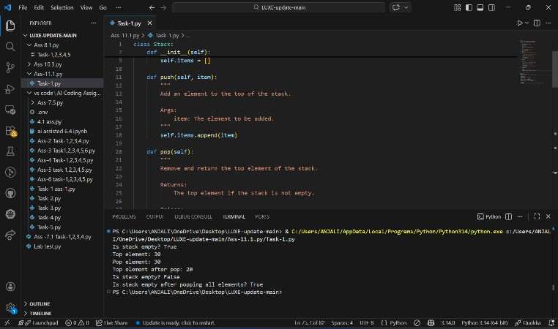
Sample Input Code:
s = Stack() s.push(10) s.push(20) s.push(30) print(s.peek())
print(s.pop()) print(s.is_empty())

Explanation:
A Stack follows the Last In First Out (LIFO) principle. The last element pushed into the stack will be the first element removed.

Expected Output: 30
30
False
Task Description #2 – Queue Implementation
Task: Use AI to implement a Queue using Python lists.

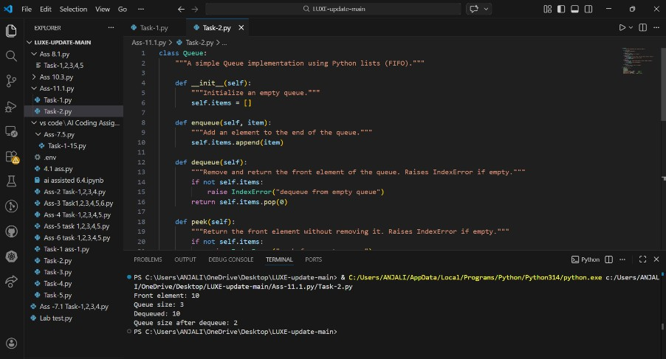
Sample Input Code:
q = Queue() q.enqueue(10) q.enqueue(20) q.enqueue(30) print(q.peek()) print(q.dequeue()) print(q.size())

Explanation:
A Queue follows the First In First Out (FIFO) principle. The first element inserted will be the first element removed.

Expected Output: 10
10
2
Task Description #3 – Linked List
Task: Use AI to generate a Singly Linked List with insert and display methods.
Explanation:
A Singly Linked List stores elements in nodes where each node points to the next node. It allows dynamic insertion of elements.

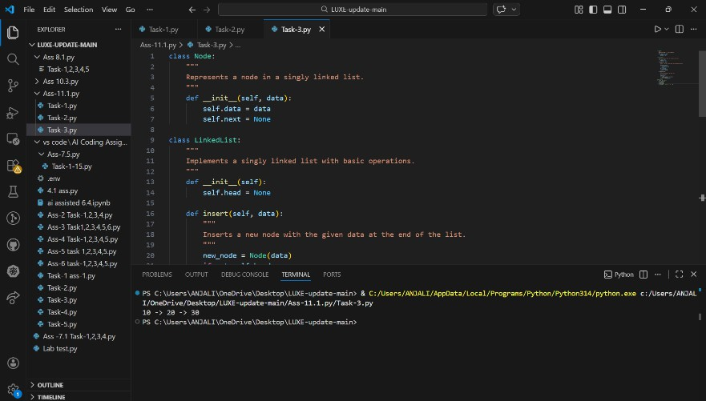
Sample Input Code: ll = LinkedList() ll.insert(10) ll.insert(20) ll.insert(30) ll.display() Expected Output: 10 -> 20 -> 30
Task Description #4 – Binary Search Tree (BST)
Task: Use AI to create a BST with insert and in-order traversal methods.
Explanation:
A Binary Search Tree stores elements such that the left child is smaller and the right child is larger than the parent node.
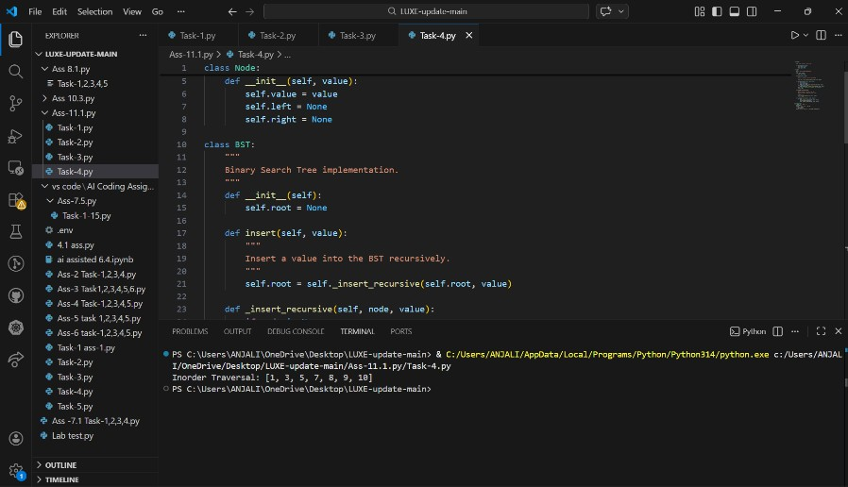
Sample Input Code: bst = BST() bst.insert(50) bst.insert(30) bst.insert(70) bst.insert(20)
bst.insert(40)

bst.inorder() Expected Output: 20 30 40 50 70
Task Description #5 – Hash Table
Task: Use AI to implement a hash table with basic insert, search, and delete methods.
Explanation:
A Hash Table stores key–value pairs and allows fast searching using a hash function. Collisions are handled using chaining
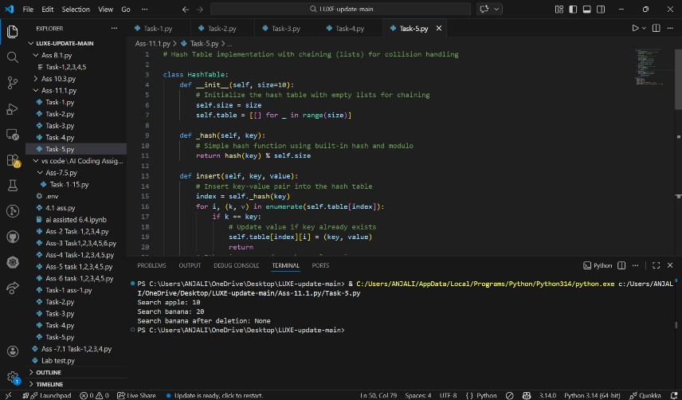
Sample Input Code: h = HashTable()
h.insert("101", "Alice")
h.insert("102", "Bob")
print(h.search("101"))
h.delete("102")
print(h.search("102")) Expected Output: Alice
None
Task Description #6 – Graph Representation
Task: Use AI to implement a graph using an adjacency list.
Explanation:
A Graph represents connections between nodes. An adjacency list stores each node and its connected neighbors.

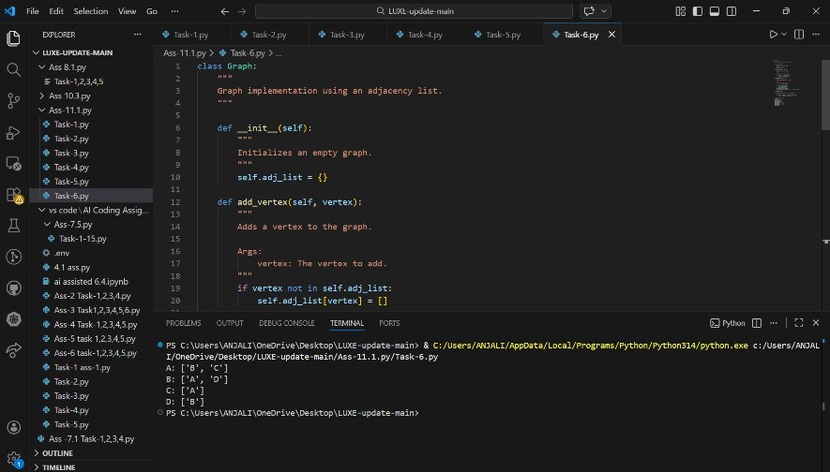
Sample Input Code:
g = Graph()
g.add_vertex("A")
g.add_vertex("B")
g.add_edge("A", "B")
g.display()
Expected Output:
A: ['B', 'C']
B: ['A', 'D']
C: ['A']
D: ['B']
Task Description #7 – Priority Queue
Task: Use AI to implement a priority queue using Python’s heapq
module.
Explanation:
A Priority Queue processes elements based on priority instead of
insertion order. Higher priority elements are served first.
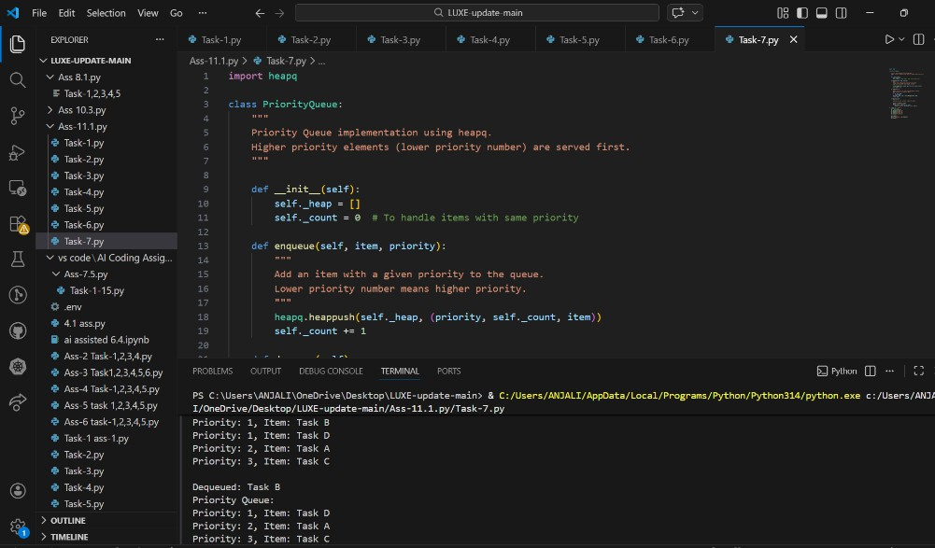

Sample Input Code: pq = PriorityQueue()
pq.enqueue("Task1", 2)
pq.enqueue("Task2", 1)
pq.enqueue("Task3", 3) print(pq.dequeue()) Expected Output:
Task2
Task Description #8 – Deque
Task: Use AI to implement a double-ended queue using collections.deque.
Explanation:
A Deque allows insertion and deletion from both the front and rear.
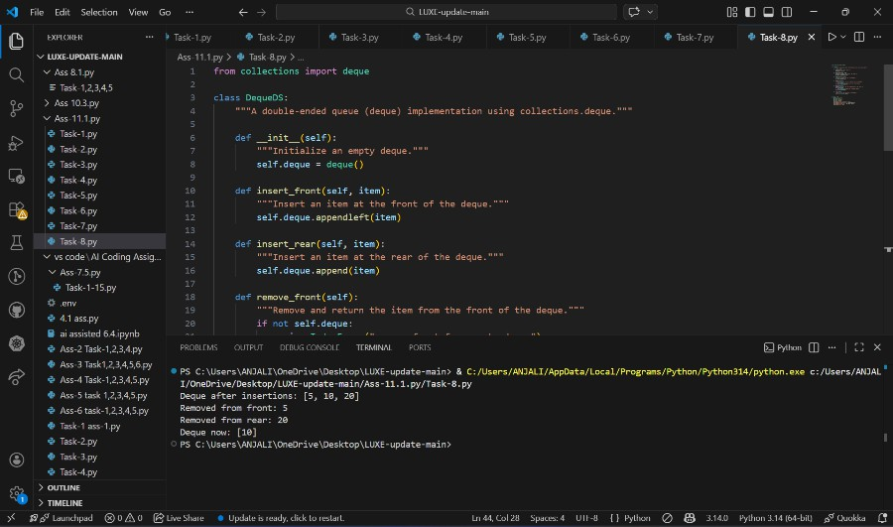
Sample Input Code: d = DequeDS() d.insert_front(10) d.insert_rear(20) d.insert_front(5) d.remove_rear() print(d.display()) Expected Output: [5, 10]
Task Description #9 Real-Time Application Challenge – Choose the Right Data Structure
Scenario:
Your college wants to develop a Campus Resource Management System that handles:
- Student Attendance Tracking – Daily log of students entering/exiting the campus.
- Event Registration System – Manage participants in events with

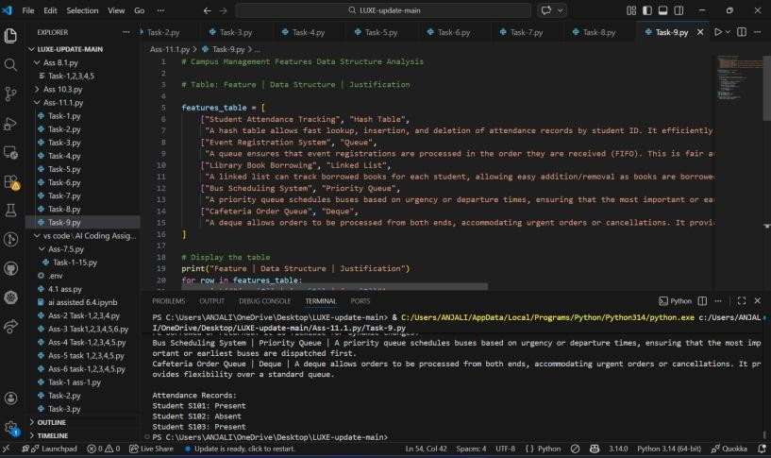
quick search and removal.
- Library Book Borrowing – Keep track of available books and their due dates.
- Bus Scheduling System – Maintain bus routes and stop connections.
- Cafeteria Order Queue – Serve students in the order they arrive.
Student Task:
  - For each feature, select the most appropriate data structure from the list below:
    - Stack
    - Queue
    - Priority Queue
    - Linked List
    - Binary Search Tree (BST)
    - Graph
    - Hash Table
    - Deque
  - Justify your choice in 2–3 sentences per feature.
  - Implement one selected feature as a working Python program with AI-assisted code generation.
Expected Output:
  - A table mapping feature → chosen data structure → justification.
  - A functional Python program implementing the chosen feature with comments and docstrings.
Explanation:
Different data structures are chosen based on how each feature handles data. Deque is used for student attendance because students enter and exit from both ends. Hash Table helps manage event registrations with fast search using IDs. Stack can manage library books using the LIFO principle. Graph represents bus routes as connected stops. Queue is used for cafeteria orders since students are served in the order they arrive (FIFO)

Expected Output:
Attendance Records:
Student S101: Present Student S102: Absent Student S103: Present

Task Description #10: Smart E-Commerce Platform – Data Structure Challenge
An e-commerce company wants to build a Smart Online Shopping System with:
- Shopping Cart Management – Add and remove products dynamically.
- Order Processing System – Orders processed in the order they are placed.
- Top-Selling Products Tracker – Products ranked by sales count.
- Product Search Engine – Fast lookup of products using product ID.
- Delivery Route Planning – Connect warehouses and delivery locations.
Student Task:
  - For each feature, select the most appropriate data structure from the list below:
    - Stack
    - Queue
    - Priority Queue
    - Linked List
    - Binary Search Tree (BST)
    - Graph
    - Hash Table
    - Deque
  - Justify your choice in 2–3 sentences per feature.

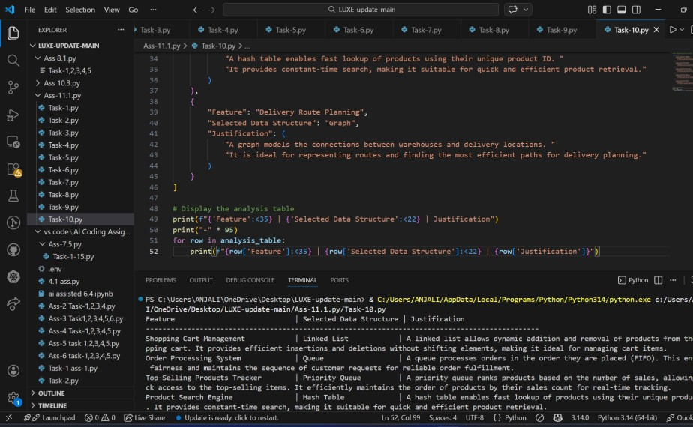  - Implement one selected f Explanation:  Different data structures improve Linked List allows easy addition cart. Queue processes orders in tracks top-selling products based fast product search using produc between warehouses and location  Expected Output:  Feature | eature as a working Python prog  efficiency in an online shoppi and removal of products in a sh  the order they are placed. Priori  on sales priority. Hash Table t IDs. Graph helps plan deliver s.  Example Input | ram with  ng system. opping  ty Queue  enables y routes
Shopping Cart Management | Add: Phone, Laptop | Cart → P
Order Processing System | Order1, Order2 | Processin
Top-Selling Products Tracker | ProductA(10), ProductB(20) | Top Prod
Product Search Engine | Search ID101 | Product F
Delivery Route Planning | Warehouse → CityA | Route: W

